Thunderhead Farm welcomes

Wolfgang Scherzer

For 3 days of Riding Instruction

March 30-April 1, 2018 (9am-6pm)

Wolfgang Scherzer, born in Germany in 1958, began his equestrian training outside of Cologne at age 12 with Master Horst Behrendt. While in Germany, he trained under Manfred Broker and Jaap Pot. Upon graduating with his Bereiter license at the young age of 19, Wolfgang began training for a local club and then briefly served in the military.

In 1983 Wolfgang moved to the United States, where he began giving clinics in Florida. He has been giving clinics throughout the country ever since. Birmingham Alabama has been his home base now for 16 years.

Throughout his career, Wolfgang has continued his own education with top trainers. In the early 1990's he had an opportunity to work with Herbert Rehbein. He returned to Germany in the late 1990s to train with Jan Bemelmans. Wolfgang's current mentor is Lilo Fore, who he began training under in 2011. In 2012, he spent 3 weeks at Lilo's farm in California working on polishing Grand Prix movements on one of his horses in training.

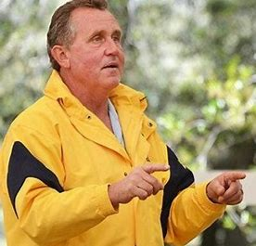

Auditors are Welcome - $20 fee includes refreshments/lunch
Riding Spots available - $160 for 45 minutes ($150 for LVDA Members)

Please contact Meredith Prange for more information
meredith_prange@yahoo.com 484-274-0326

