Thunderhead Farm welcomes

Patrick King

For 3 days of Riding Instruction

June 8-10, 2018 (9am-6pm)

PATRICK KING HORSEMANSHIP
Classical principles for modern riders.
By combining REAL HORSEMANSHIP and CLASSICAL DRESSAGE, Patrick King can help make your goals a reality. Many friends and mentors have shaped Patrick’s philosophies and approach to the horse… Ray Hunt, Mark Russell, Charles De Kunffy, Julio Mendoza, and others.

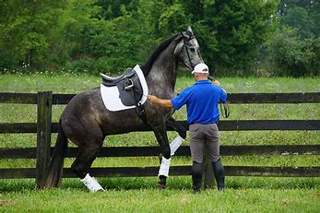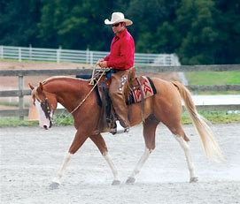

Auditors are Welcome - $20 fee includes refreshments/lunch
Riding Spots available - $160 for 1 hour ($150 for LVDA Members)

Please contact Meredith Prange for more information
meredith_prange@yahoo.com 484-274-0326

